Grade 7 Accelerated · Unit 3 · Thread A · Day 1  Exponent Laws with Variable Bases  Question Bank - Additional 3.T1 ANSWER KEY | Name  Date  Period

Show your work. Circle your final answer.
For questions 1 through 6, write an equivalent expression as a single monomial. Assume no variable equals 0.
1. 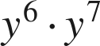


2. 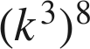
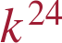

3. 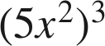
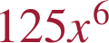

4. 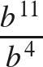


5. 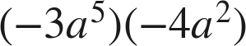


6. 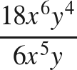
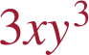

For questions 7 and 8, apply more than one law. Write each answer as a single monomial.
7. Write an equivalent expression.
a. 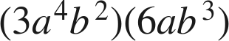

b. 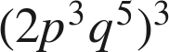

c. 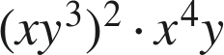
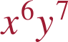

8. Write an equivalent expression.
a. 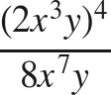
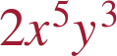
16x¹²y⁴ over 8x⁷y.
b. 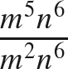

n⁰ = 1.
c. 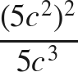

25c⁴ over 5c³.

Working backwards.
9. Find the value of that makes each statement true.
a. 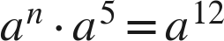
n = 7
b. 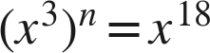
n = 6
c. 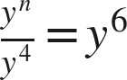
n = 10
n − 4 = 6.

10. A rectangle has length 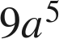 and width 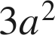.
a. Write its area as a single monomial.

b. A square has side length 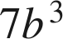. Write its area as a single monomial.


11. Which expression is equivalent to 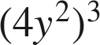 ?
○ A. 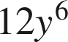
○ B. 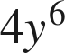
● C. 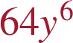
○ D. 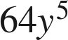
C

12. Select ALL of the expressions that are equivalent to 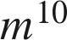.
☒ A. 
☒ B. 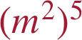
☐ C. 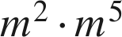
☐ D. 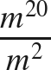
☒ E. 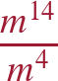
☒ F. 
A, B, E and F

